DEPARTMENT OF INFORMATION TECHNOLOGY NITK SURATHKAL

IT 301 Parallel Computing (Minor )

Lab 2

Date: 07th January 2021

**Objectives:**

To understand the system configuration with respect to number of processors, memory etc.

**Note:**

**(i) Screen shot must be attached for each question. If the content of each command is very long, then put screen shot of first page obtained in each command execution.**

**(ii) System name must be visible in the screen shot.**

**itadmin@mysystem:~$ cat /proc/cpuinfo**

**(iii)Marks for each question**:

|  |  |
| --- | --- |
| **Q No** | **Marks** |
| 1 | 3 marks |
| 2 | 2 marks |
| 3 | 2 marks |
| 4 | 2 marks |
| 5 | 1 mark |

Reference material : https://www.tecmint.com/check-linux-cpu-information/

**Question 1. To get CPU information using cat command**

**You can simply view the information of your system CPU by viewing the contents of the /proc/cpuinfo file with the help of cat command as follows:**

***cat /proc/cpuinfo***

itadmin@mysystem:~$ cat /proc/cpuinfo

processor : 0

vendor_id : GenuineIntel

cpu family : 6

model : 158

model name : Intel(R) Core(TM) i7-9700 CPU @ 3.00GHz

stepping : 13

microcode : 0xde

cpu MHz : 812.236

cache size : 12288 KB

physical id : 0

siblings : 8

core id : 0

cpu cores : 8

apicid : 0

initial apicid : 0

fpu : yes

fpu_exception : yes

cpuid level : 22

wp : yes

……………………………………….(long list of information for each processor)

**Write your observation with respect to following parameters**

**a. How many processors are there in your system?**

**b. Whether any graphics card is available in your system?**

**c. Write following information with respect to each processor in you system.**

|  |  |  |  |  |
| --- | --- | --- | --- | --- |
| **Processor** | **Processor id** | **Speed of processor (MHz)** | **Model name** | **Cache size** |
| **1** |  |  |  |  |
| **2** |  |  |  |  |
| **…..** |  |  |  |  |

**Question 2. Following commands can be used to get specific information.**

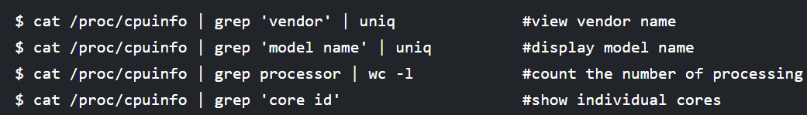

**Run each of the above commands and Paste the picture of the results here.**

**a) to view vendor name**

**b)To display model name**

**c) Count the number of processing elements**

**d) Show individual cores**

**Question 3. The command lscpu prints CPU architecture information from sysfs and /proc/cpuinfo as shown below:**

itadmin@mysystem:~$ lscpu

Architecture: x86_64

CPU op-mode(s): 32-bit, 64-bit

Byte Order: Little Endian

CPU(s): 8

On-line CPU(s) list: 0-7

Thread(s) per core: 1

Core(s) per socket: 8

Socket(s): 1

NUMA node(s): 1

Vendor ID: GenuineIntel

CPU family: 6

Model: 158

Model name: Intel(R) Core(TM) i7-9700 CPU @ 3.00GHz

Stepping: 13

CPU MHz: 900.045

CPU max MHz: 4700.0000

CPU min MHz: 800.0000

BogoMIPS: 6000.00

Virtualization: VT-x

L1d cache: 32K

L1i cache: 32K

L2 cache: 256K

L3 cache: 12288K

NUMA node0 CPU(s): 0-7

**a) Note down the architecture, byte order, number of CPU, types of cache present and its size.**

**Question 4. The command cpuid dumps complete information about the CPU(s) collected from the CPUID instruction, and also discover the exact model of x86 CPU(s) from that information.**

itadmin@mysystem:~$ cpuid

Command 'cpuid' not found, but can be installed with:

sudo apt install cpuid

itadmin@mysystem:~$ sudo apt install cpuid

[sudo] password for itadmin:

Reading package lists... Done

Building dependency tree

Reading state information... Done

The following packages were automatically installed and are no longer required:

linux-headers-5.4.0-56-generic linux-hwe-5.4-headers-5.4.0-42

……….. (long list of information )

itadmin@mysystem:~$ cpuid

CPU 0:

vendor_id = "GenuineIntel"

version information (1/eax):

processor type = primary processor (0)

family = Intel Pentium Pro/II/III/Celeron/Core/Core 2/Atom, AMD Athlon/Duron, Cyrix M2, VIA C3 (6)

model = 0xe (14)

stepping id = 0xd (13)

extended family = 0x0 (0)

extended model = 0x9 (9)

(simple synth) = Intel Core i5-7000 / i5-7000K / i5-7000T / i7-7000 / E3-15x5MV6 / i3-7100H / i5-7000HQ / i7-7000HQ (Kaby Lake), 14nm

miscellaneous (1/ebx):

………….. [large list of information]

**a) Write /highlight the information about Translation Lookaside Buffer (TLB).**

**Question 5. To find number of processes present in a system use nproc command.**

itadmin@mysystem:~$ nproc

8